  

**Automating Data Population In**

**ServiceNow: Streamlining Program Management**

**Submitted by:**

**1.BOLLINENI NARASIMHA NAIDU au723921244011**

**Arjun College Of Technology, Coimbatore**

**Anna University, Chennai**

**Project Overview:**

The project titled "Automating Data Population in ServiceNow: Streamlining Program Management" is a strategic initiative aimed at addressing the challenges of manual data entry and inefficiencies in program management within an organization. The primary objective of this project is to automate the data population processes in ServiceNow, a leading platform for IT Service Management (ITSM) and enterprise automation. By doing so, the project seeks to eliminate redundancies, reduce human error, and enhance the overall operational efficiency of program management tasks.

The core challenge this project addresses is the time-consuming and error-prone nature of manually inputting and updating data across various ServiceNow modules. These manual processes often result in delays, inaccuracies, and difficulties in maintaining up-to-date records, which in turn hinders decision-making and project visibility. The overarching goal of this initiative is to leverage ServiceNow's automation capabilities, such as its IntegrationHub and orchestration tools, to streamline data entry processes, ensuring that program managers and stakeholders have access to real-time, accurate information.

By automating these processes, the project aims to improve key aspects such as data accuracy, workflow efficiency, and the speed with which information is updated and shared across teams. This, in turn, will enhance program management capabilities, allowing for better resource allocation, tracking of milestones, and reporting of key performance indicators (KPIs). The long-term objective is to support the organization's broader goals of digital transformation, operational excellence, and improved service delivery.

**2.Objectives**

The project "Automating Data Population in ServiceNow: Streamlining Program Management" is designed to achieve specific business and operational goals. Below are the measurable objectives the project aims to accomplish.

**Business Goals:**

1. **Increase Operational Efficiency:**
   * **Goal:** Automate at least 80% of manual data entry tasks across ServiceNow modules (such as incident management, change management, and project management).
   * **Measurement:** The percentage of data population tasks automated compared to manual processes before the project.
   * **Target:** Complete automation of 80% of all routine data entry processes within the first 6 months of deployment**.**
2. **Reduce Human Error in Data Entry:**
   * **Goal:** Minimize the occurrence of data inaccuracies resulting from manual data entry.
   * **Measurement:** Track the number of data errors reported before and after automation implementation.
   * **Target:** Reduce data entry errors by 90% within the first quarter after the solution goes live.
3. **Enhance Real-Time Data Availability:**
   * **Goal:** Ensure that all critical program management data is automatically updated in real-time, providing stakeholders with up-to-date information.
   * **Measurement:** Real-time updates frequency and the reduction in lag time between data input and its reflection in the system.
   * **Target:** Achieve a 100% real-time update rate for all program management data.
4. **Cost Savings from Efficiency Gains:**
   * **Goal:** Achieve cost savings by reducing the time and effort spent on manual data population and correcting data errors.
   * **Measurement:** Track reduction in labour costs related to manual data entry and error resolution.
   * **Target:** Save 20% of the annual operational costs associated with data management within the first year of implementation.

**Specific Outcomes:**

1. **Automated Data Population Workflows:**
   * **Deliverable:** Develop and deploy automated workflows in ServiceNow to handle data population tasks, including the use of ServiceNow’s Flow Designer, Integration Hub, and orchestration tools.
   * **Measurement:** Number of workflows implemented and the percentage of data population tasks covered by automation.
   * **Target:** Implement at least 15 automated workflows across critical modules such as Incident Management, Change Management, and Project Management**.**
2. **Integration with External Data Sources:**
   * **Deliverable:** Integrate ServiceNow with key external systems (e.g., HR systems, external project tracking tools, etc.) to automatically pull relevant data for population into the ServiceNow platform.
   * **Measurement:** Number of successful integrations and the amount of data imported automatically from external sources.
   * **Target:** Integrate at least 3 external data sources into ServiceNow for automatic data population.
3. **Error Reduction and Data Validation:**
   * **Deliverable:** Implement automated data validation rules and error-checking mechanisms to ensure data accuracy and consistency.
   * **Measurement:** The reduction in reported data errors and the percentage of records passing validation checks without manual intervention.
   * **Target:** Achieve a 90% pass rate on automated validation checks, reducing manual error corrections.
4. **User Adoption and Training:**
   * **Deliverable:** Conduct training sessions for program managers and administrators to ensure effective use of the new automated processes.
   * **Measurement:** Number of users trained, training completion rates, and user feedback on the ease of use and effectiveness of the automation.
   * **Target:** Train at least 100 users, with 95% of participants reporting increased satisfaction and ease of use post-training.
5. **Reporting and Insights:**
   * **Deliverable:** Develop real-time, automated reporting capabilities to provide key performance indicators (KPIs) related to program management activities.
   * **Measurement:** Frequency and accuracy of automated reports generated, and user feedback on the utility of the reports for decision-making.
   * **Target:** Generate automated reports for program management with a 100% accuracy rate and daily frequency.

**3. Key Features and Concepts Utilize:**

**1. ServiceNow Flow Designer**

* **Feature:** Flow Designer is a powerful, no-code tool within ServiceNow used to automate business processes, integrate systems, and orchestrate tasks. It provides a graphical interface to design workflows, making it easy to build automation without deep coding expertise.
* **Application in Project**: Flow Designer was used to create automated workflows for data population. These workflows can trigger actions such as creating or updating records, sending notifications, and executing business logic, all without manual intervention. For instance, when a new program or project record is created, Flow Designer automatically populates related fields and modules with the necessary data.
* **Key Benefit:** Simplifies the creation of automation processes, reducing the complexity and time associated with traditional coding methods.

**2. ServiceNow Integration Hub**

* **Feature:** Integration Hub provides a suite of tools for integrating external systems, applications, and data sources into the ServiceNow platform. It enables seamless data exchange between ServiceNow and third-party systems using pre-built connectors or custom integration logic.
* **Application in Project:** Integration Hub was used to automate the import of data from external systems, such as HR databases, project management tools, or finance software, directly into ServiceNow. This ensured that program managers always had the latest information, such as resource availability or project budgets, without needing to manually input this data.
* **Key Benefit:** Enables real-time data synchronization between ServiceNow and other systems, improving data consistency and reducing manual data entry errors.

**3. ServiceNow Data Import and Transformation**

* **Feature:** ServiceNow provides a robust data import functionality to bring data from various sources into the platform. It includes tools for transforming and mapping incoming data into the correct structure for ServiceNow tables and fields.
* **Application in Project:** This feature was used to import bulk data from legacy systems or external databases into ServiceNow, ensuring that data was formatted correctly and accurately populated into the system. Transformations were applied to match ServiceNow's data model, eliminating the need for manual corrections.
* **Key Benefit:** Simplifies the process of migrating and importing data, ensuring data integrity and minimizing manual effort during data population.

**4.. ServiceNow Security and Access Controls**

* **Feature:** ServiceNow provides granular security controls, including role-based access controls (RBAC) and permissions, to ensure that only authorized users can view, edit, or interact with specific data.
* **Application in Project:** Security and access controls were used to ensure that sensitive data, such as financial details or confidential project information, is only accessible to authorized users. Automated data population workflows adhere to these security settings, ensuring compliance and protecting sensitive information.
* **Key Benefit:** Enhances data security by ensuring that access to data is controlled and restricted based on user roles and permissions.

**5. Security and Permissions**

* **Access Control Lists (ACLs)**: ServiceNow’s ACLs ensure that only authorized users can access or modify specific data. This is crucial when automating the population of sensitive program management data.
* **Role-based Access Control (RBAC)**: RBAC is used to define who can interact with the automation processes and data based on their roles. Ensuring that only users with the proper permissions can modify program management data protects both the integrity and security of the system.

**6. Scheduled Jobs and Scripting**

* **Scheduled Jobs**: ServiceNow allows for the creation of scheduled jobs that run at defined intervals to automate recurring tasks. This is useful for regularly updating or importing program data from external systems.
* **Script Includes**: Reusable server-side scripts, called Script Includes, are used for modular automation and handling complex logic behind data imports and transformations.

1. **Detailed Steps to Solution Design**

**STEP 1:** First, we need login our Naan Mudhalvan portal in that we select watch progress and there will project little

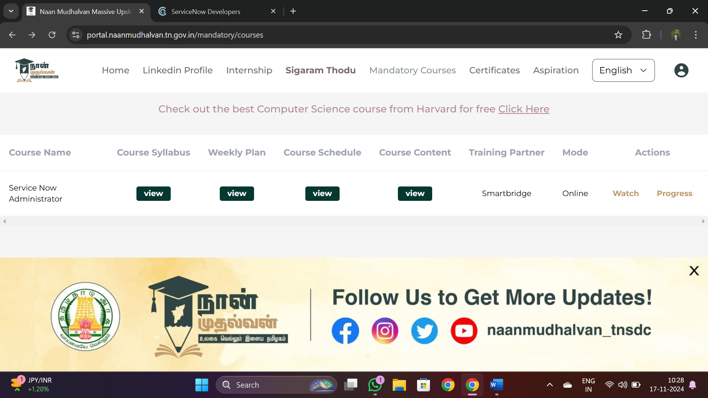

**STEP 2:** After login into that then we can find that our project title

i.e. **Automating Data Population in ServiceNow: Streamlining Program Management**

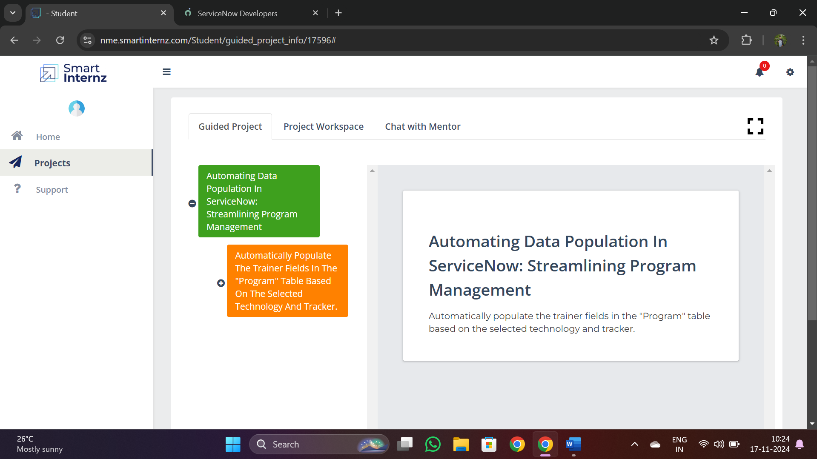

**STEP 3:** Now we want login into ServiceNow Developer website

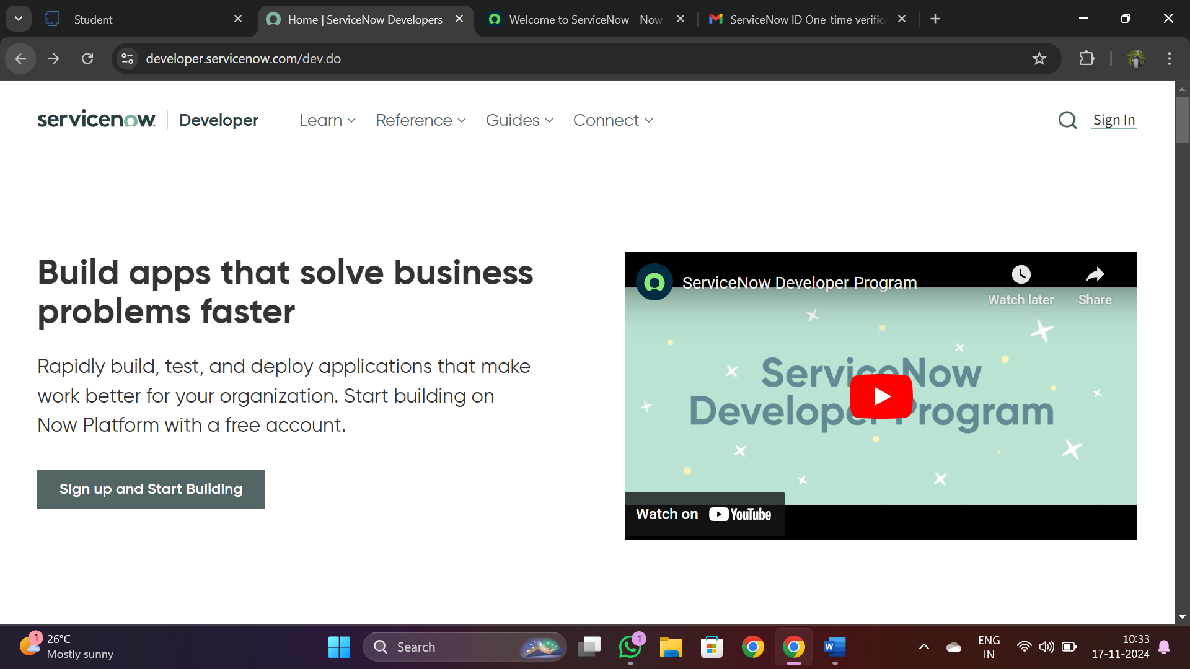

**STEP 4:** Login into that website and login by using register e mail.id which you given to ServiceNow learning platform**.**

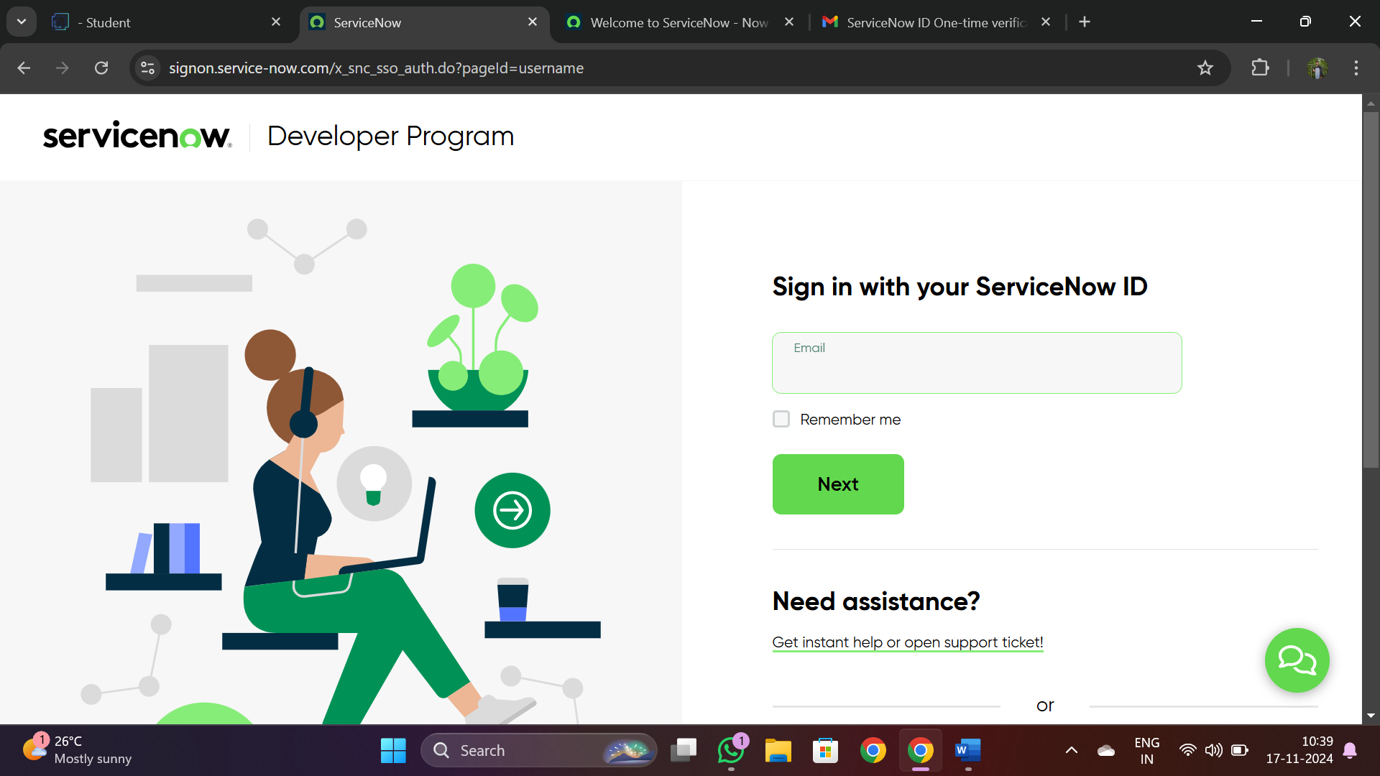

**STEP 5: By entering that mail id and password and we get OTP for Verification after we will login into that web page then**

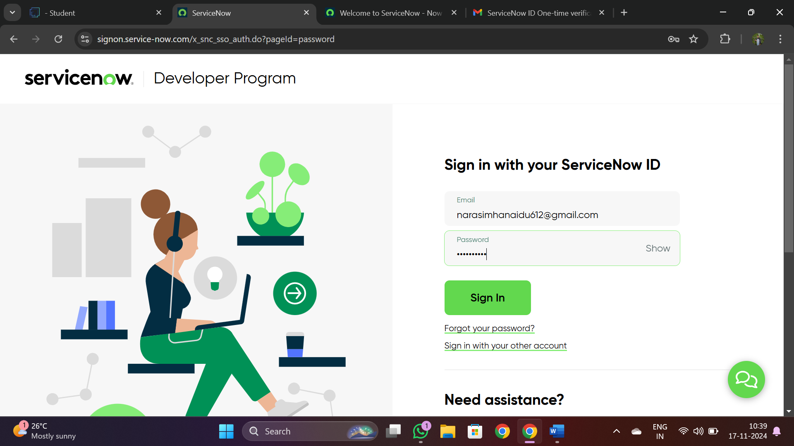

**STEP 6: This the home screen for service now developer ,then we need start building of our project by following implementation process**

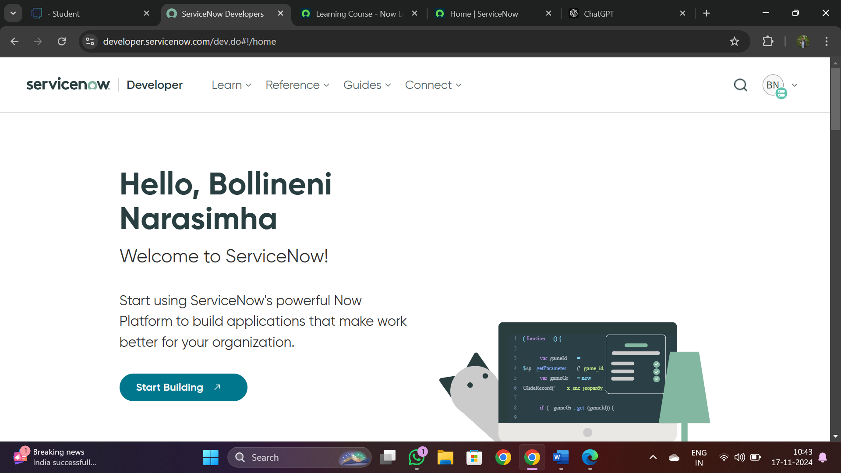

**Implementation**

**Step 1 : Creating Custom Table**

1. **Open “Tables” >> New.**

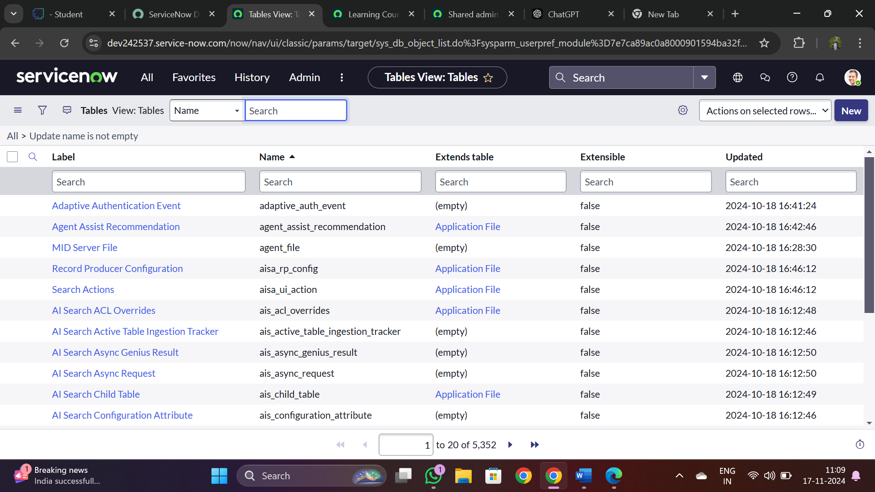

**2.Give the label name as “program”.**

**3. Click on Submit.**

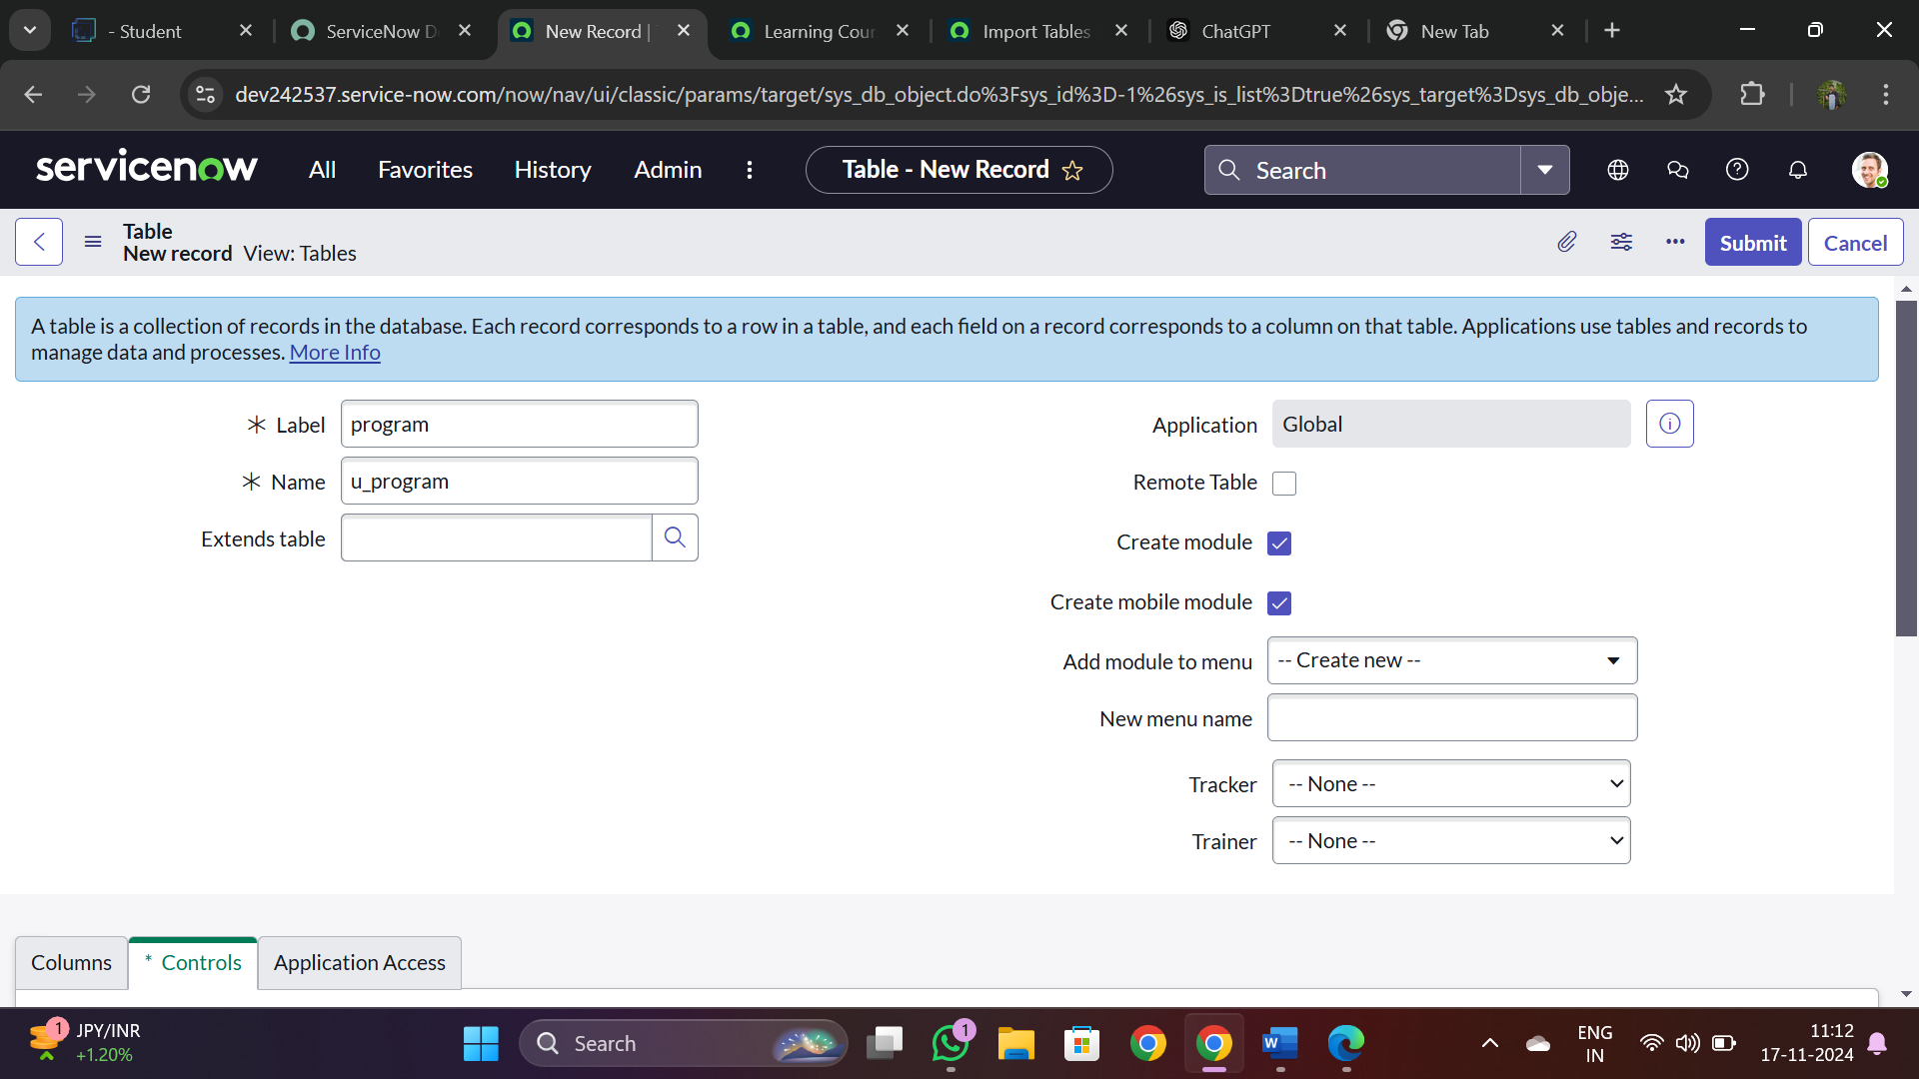

* 1. Click on new to open record, click on the Additional Actions and go to configure >> select Form Layout.

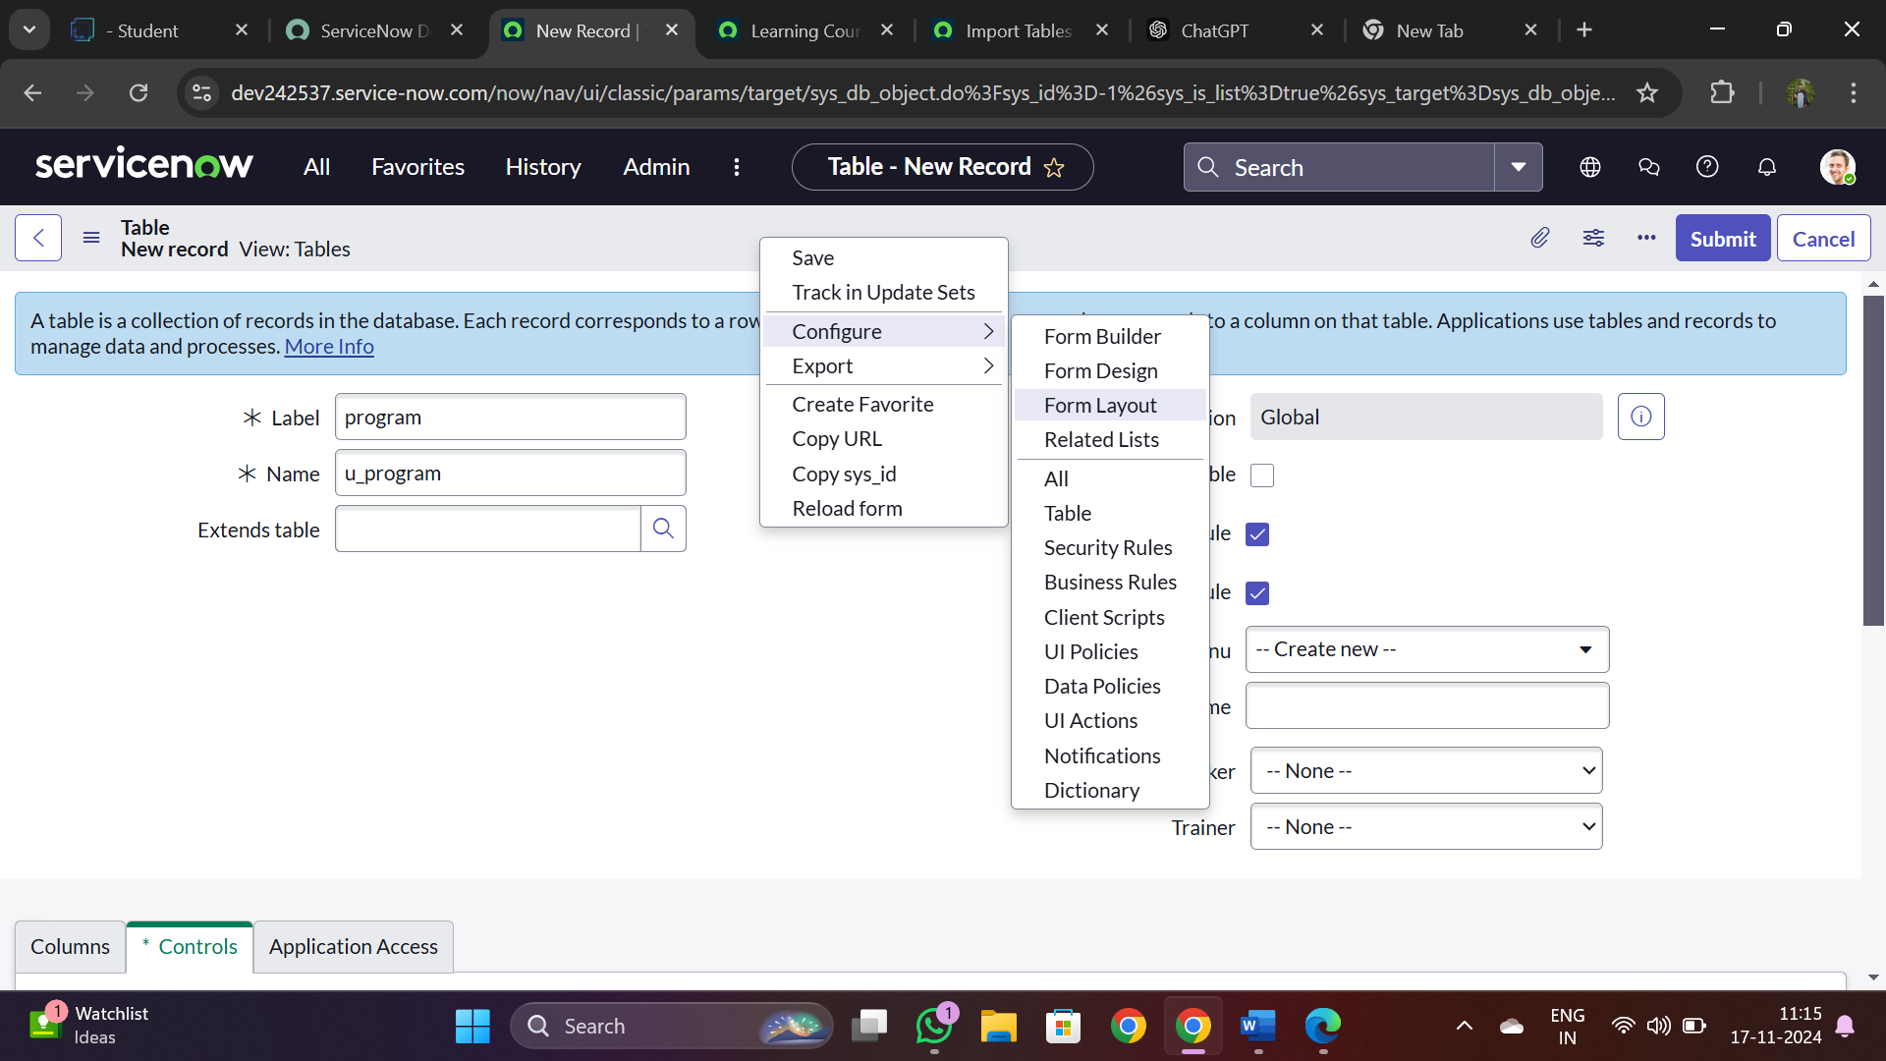

1. **Create fields as**

A. Name : Technology

B .Type : choice

1. **Click on Add**
2. **And follow the same instructions**
3. **For two more fields are**
   1. **Tracker**
   2. **Trainer**
4. **Add them and click on save.**

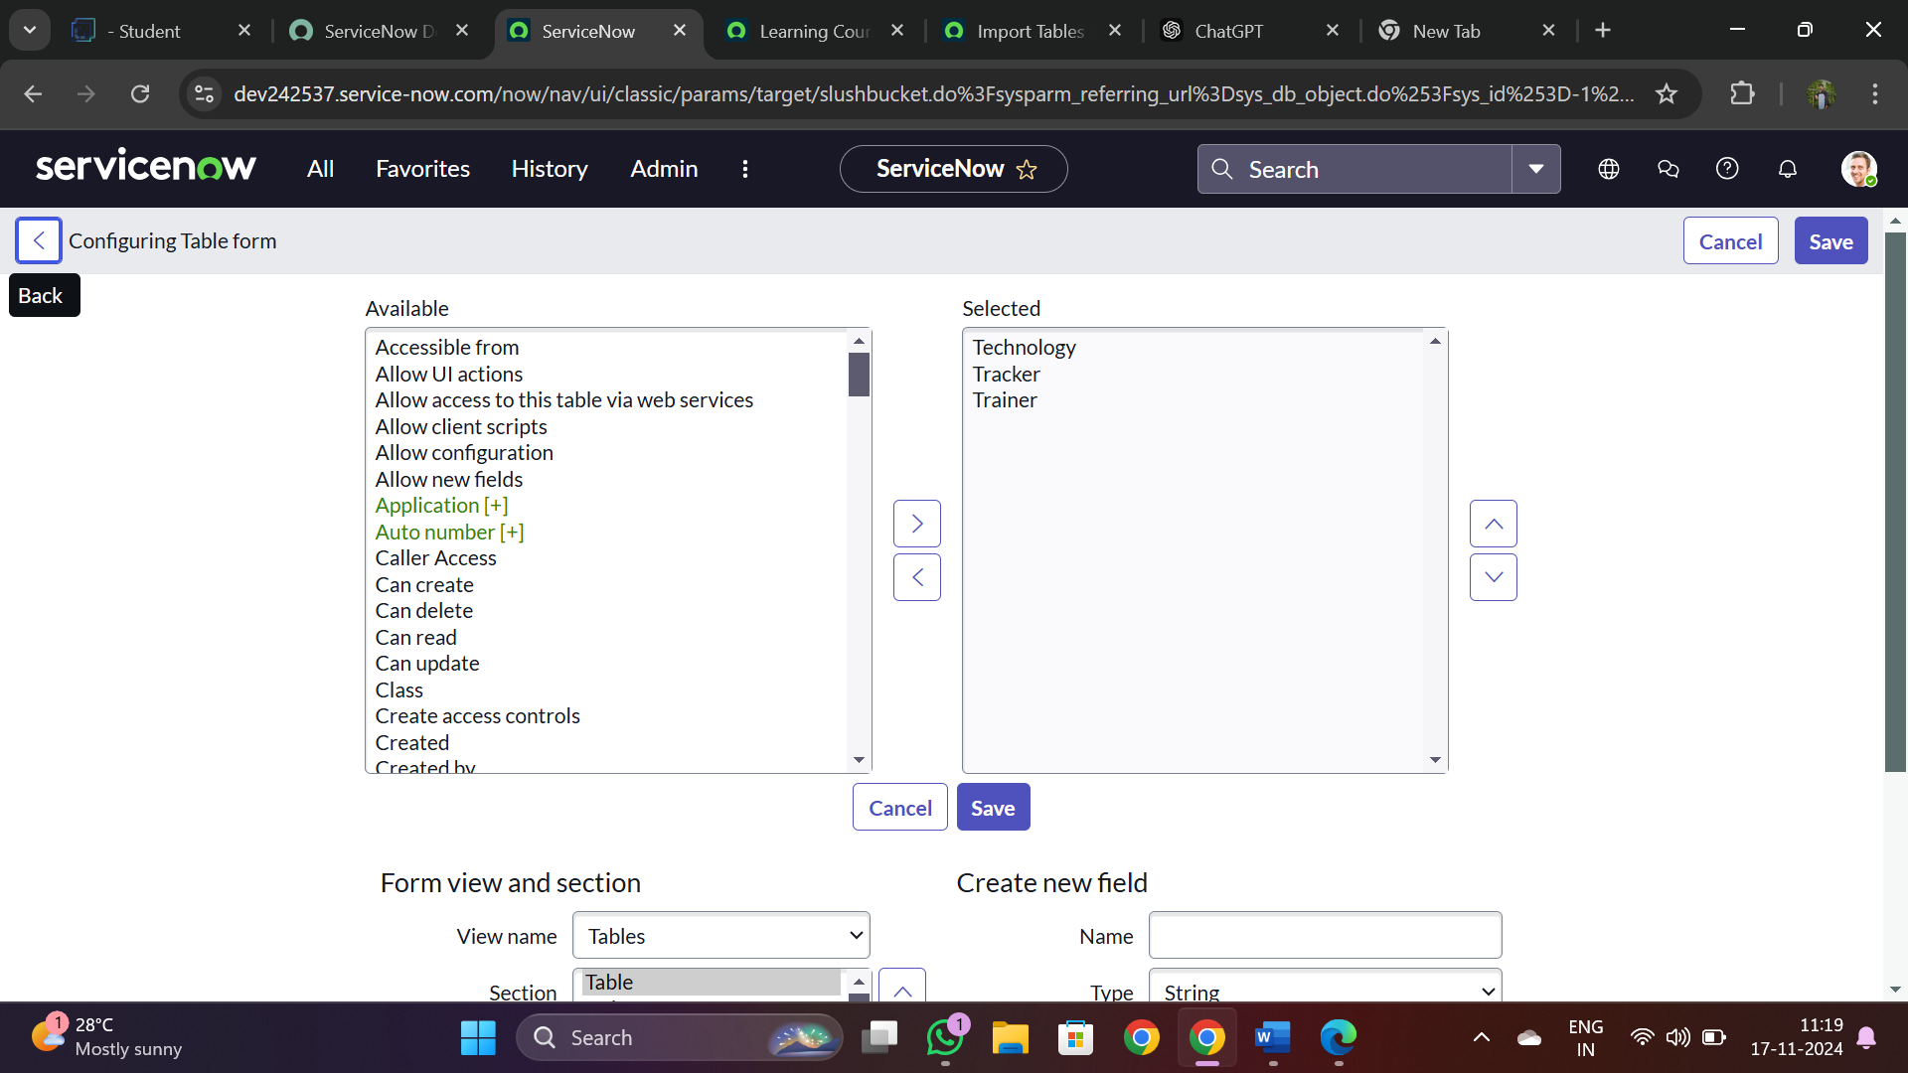

1. **Now right click on “technology” field click on Configure Choices.**
2. **Enter the item as “Salesforce” and click on Add.**
3. **Add two more items**

**a. ServiceNow**

**b. Testing**

1. **Click on save.**

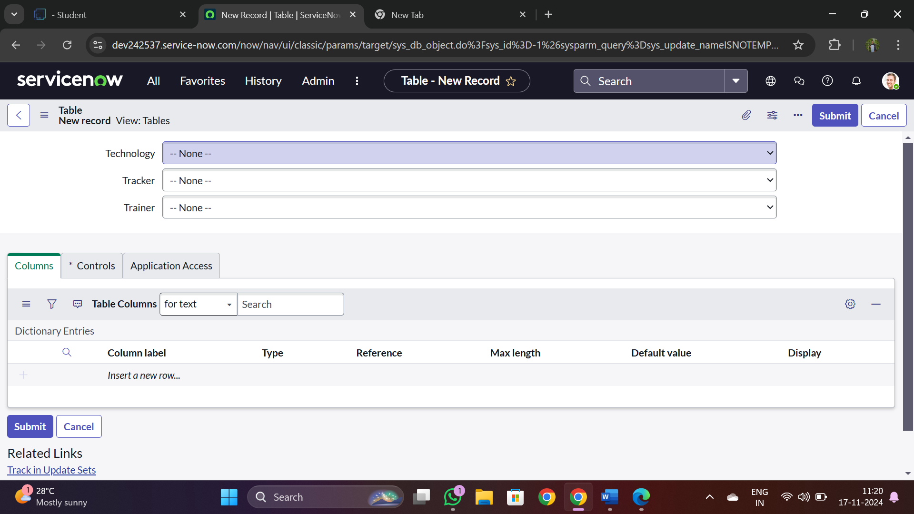

1. **Follow the same steps from 9 to 13 for remaining two fields.**
2. **Tracker values are:**
   1. **Admin**
   2. **Developer**
3. **Trainer values are:**
   1. **Rakesh**
   2. **Tarakesh**
   3. **Ajay**
   4. **Phani**
   5. **Shivam**
4. **Click on save.**

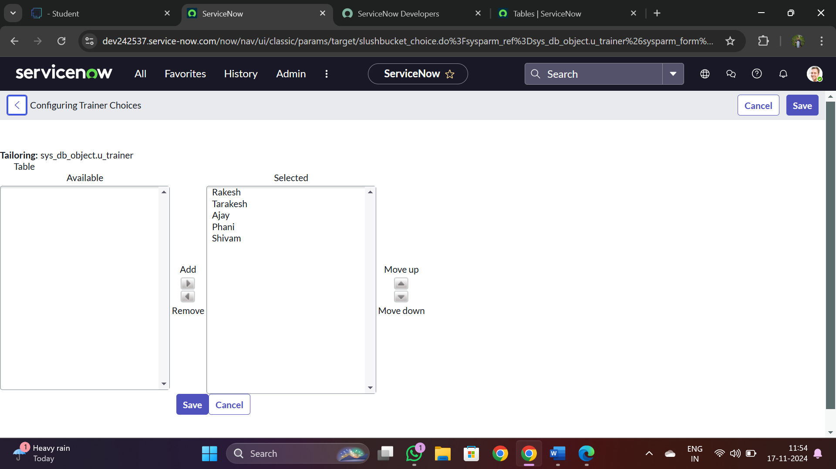

**Step 2 : Creating a custom matcher table.**

1. **Open “Tables” >> New.**
2. **Give the label name as “ testing lookup ”.**
3. **Add “ Matcher Field Definition ” in the Extends table field.**
4. **Click on Submit.**

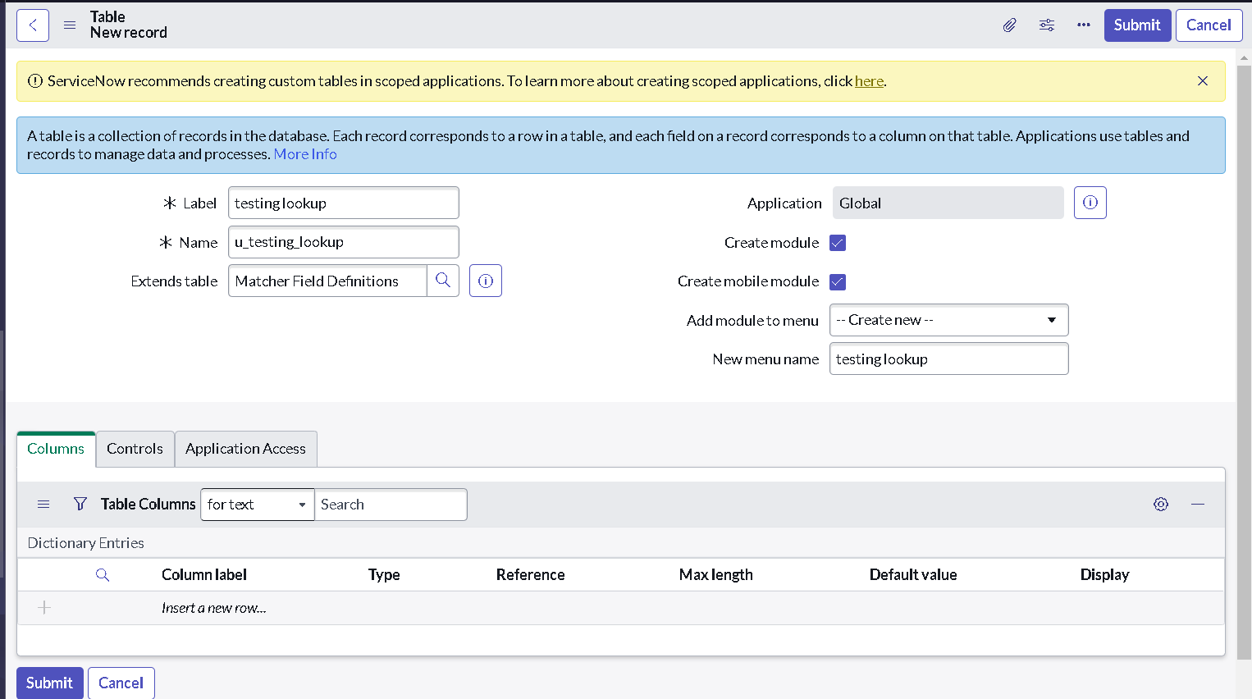

**Step 3 : Create records in matcher table**

1. **Follow the below figure to create a record.**

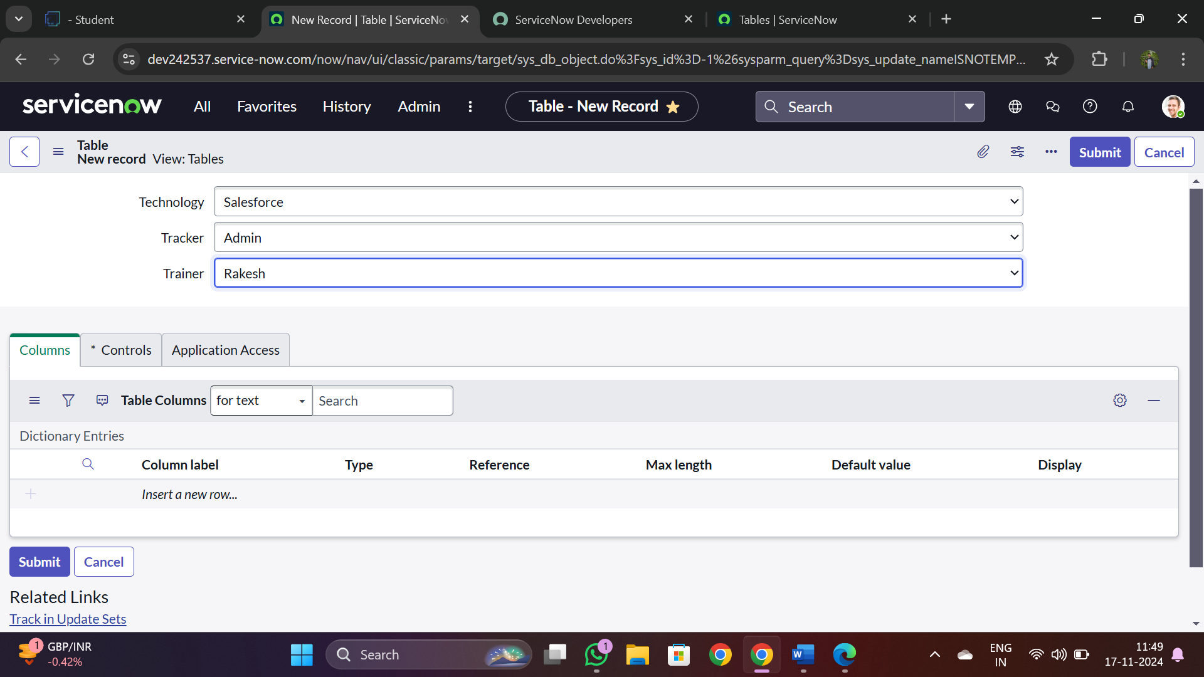

1. Follow the figure to create more records as shown in below figure.

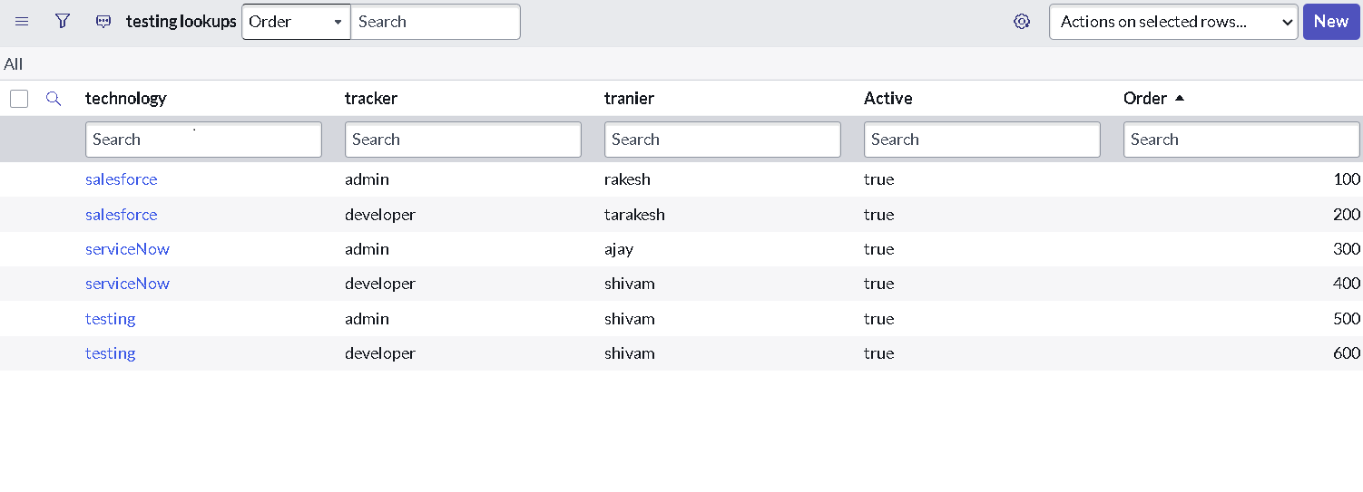

**Step 4 : Create Data Lookup Definition to automate the trainer**

1. **Search for Data Lookup Definition in All navigation.**
2. **Click on new.**
3. **Give name as “ program data lookup ”**
4. **Select the source table as “ program ”.**
5. **Select the matcher table as “ testing lookup ”.**
6. **Click on submit.**

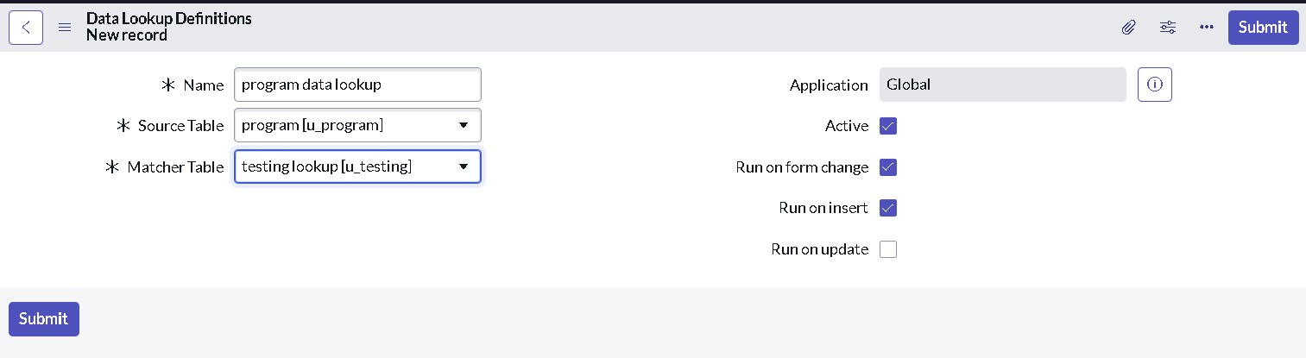

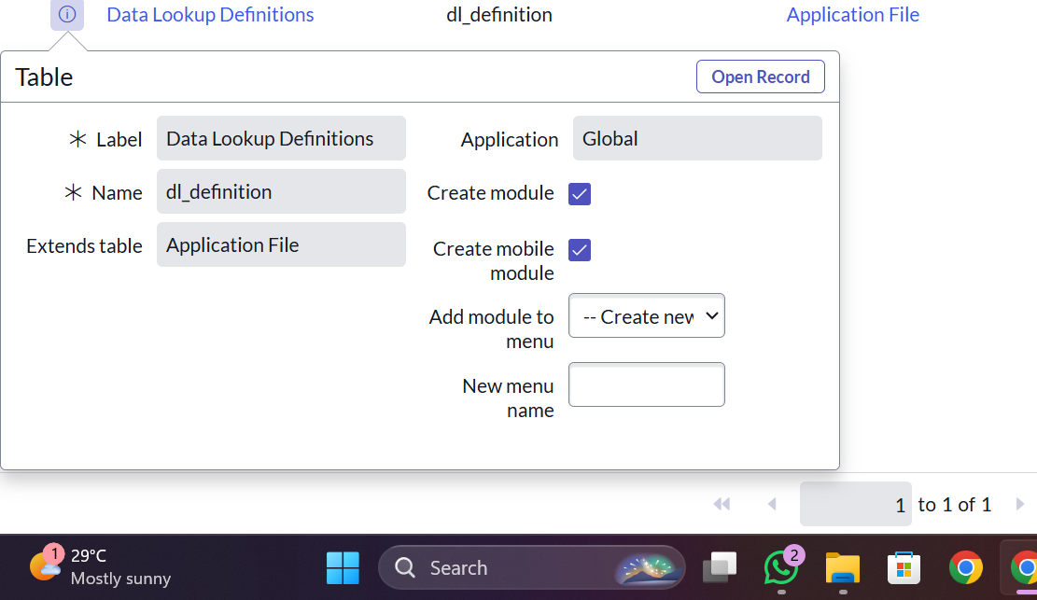

Click on update.

Then it last step and we all output that and we all completed implementation steps

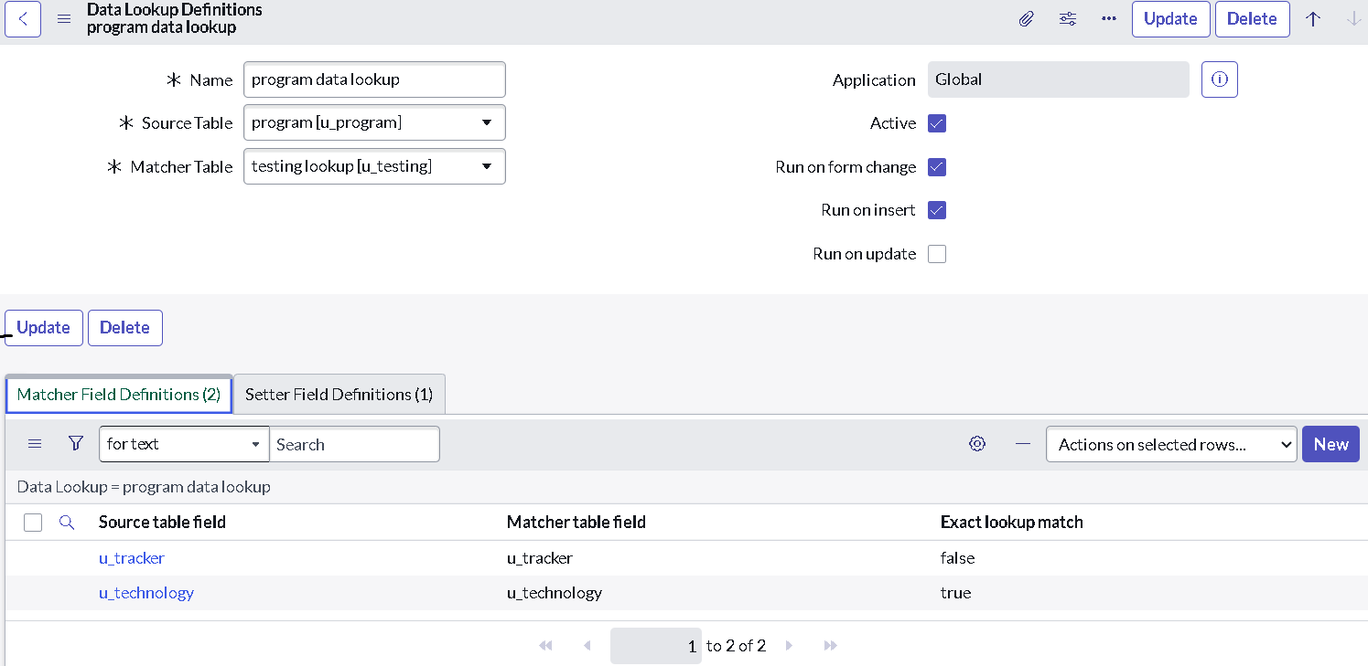

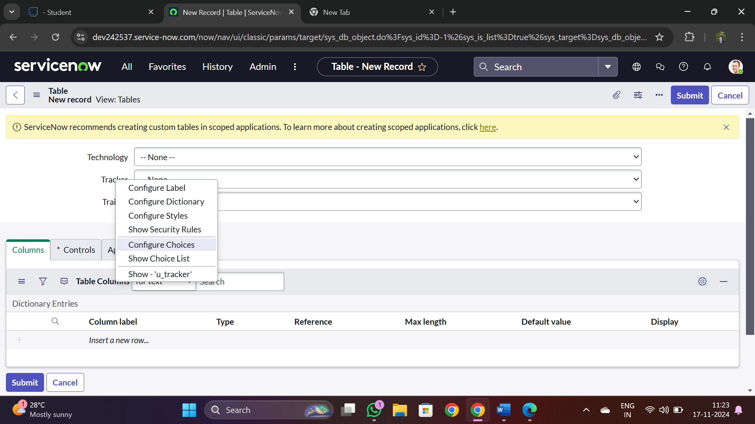

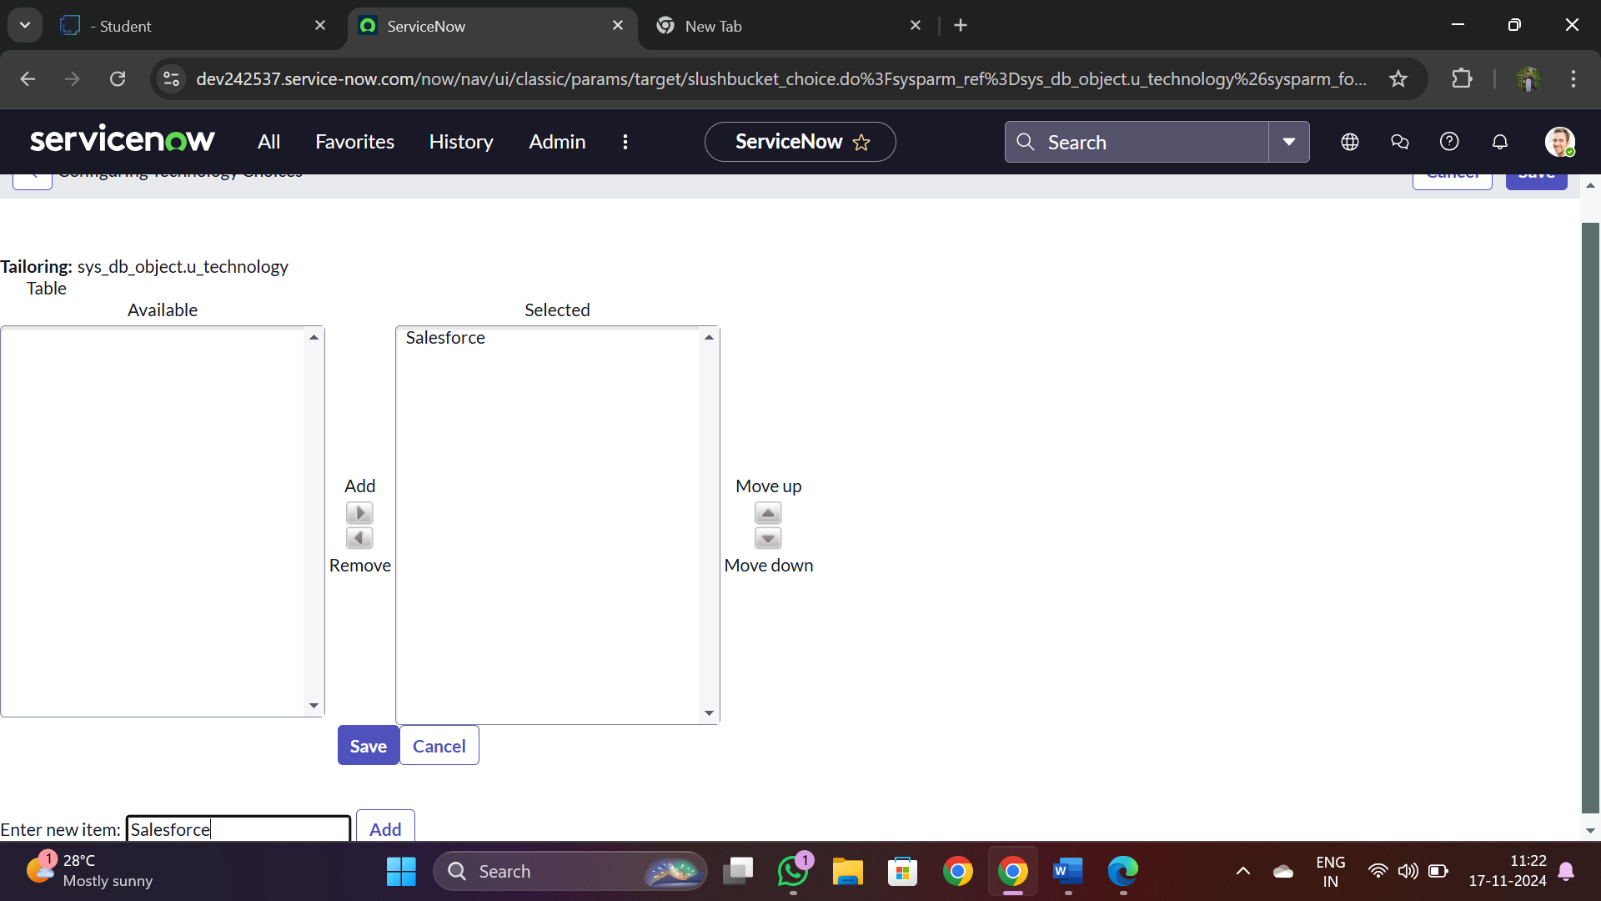

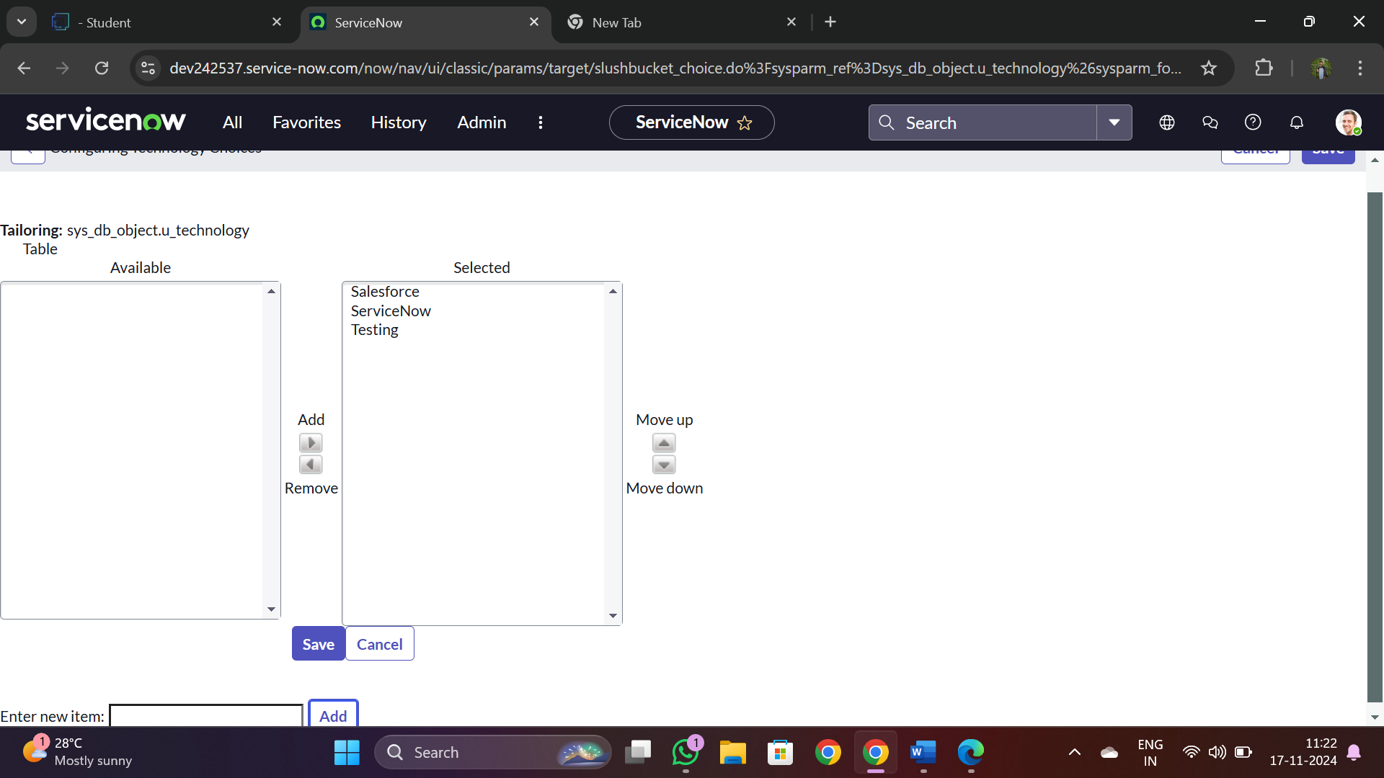

Then all septs we need to follow up and we need make each other’s follows each steps by adding all required things and names .

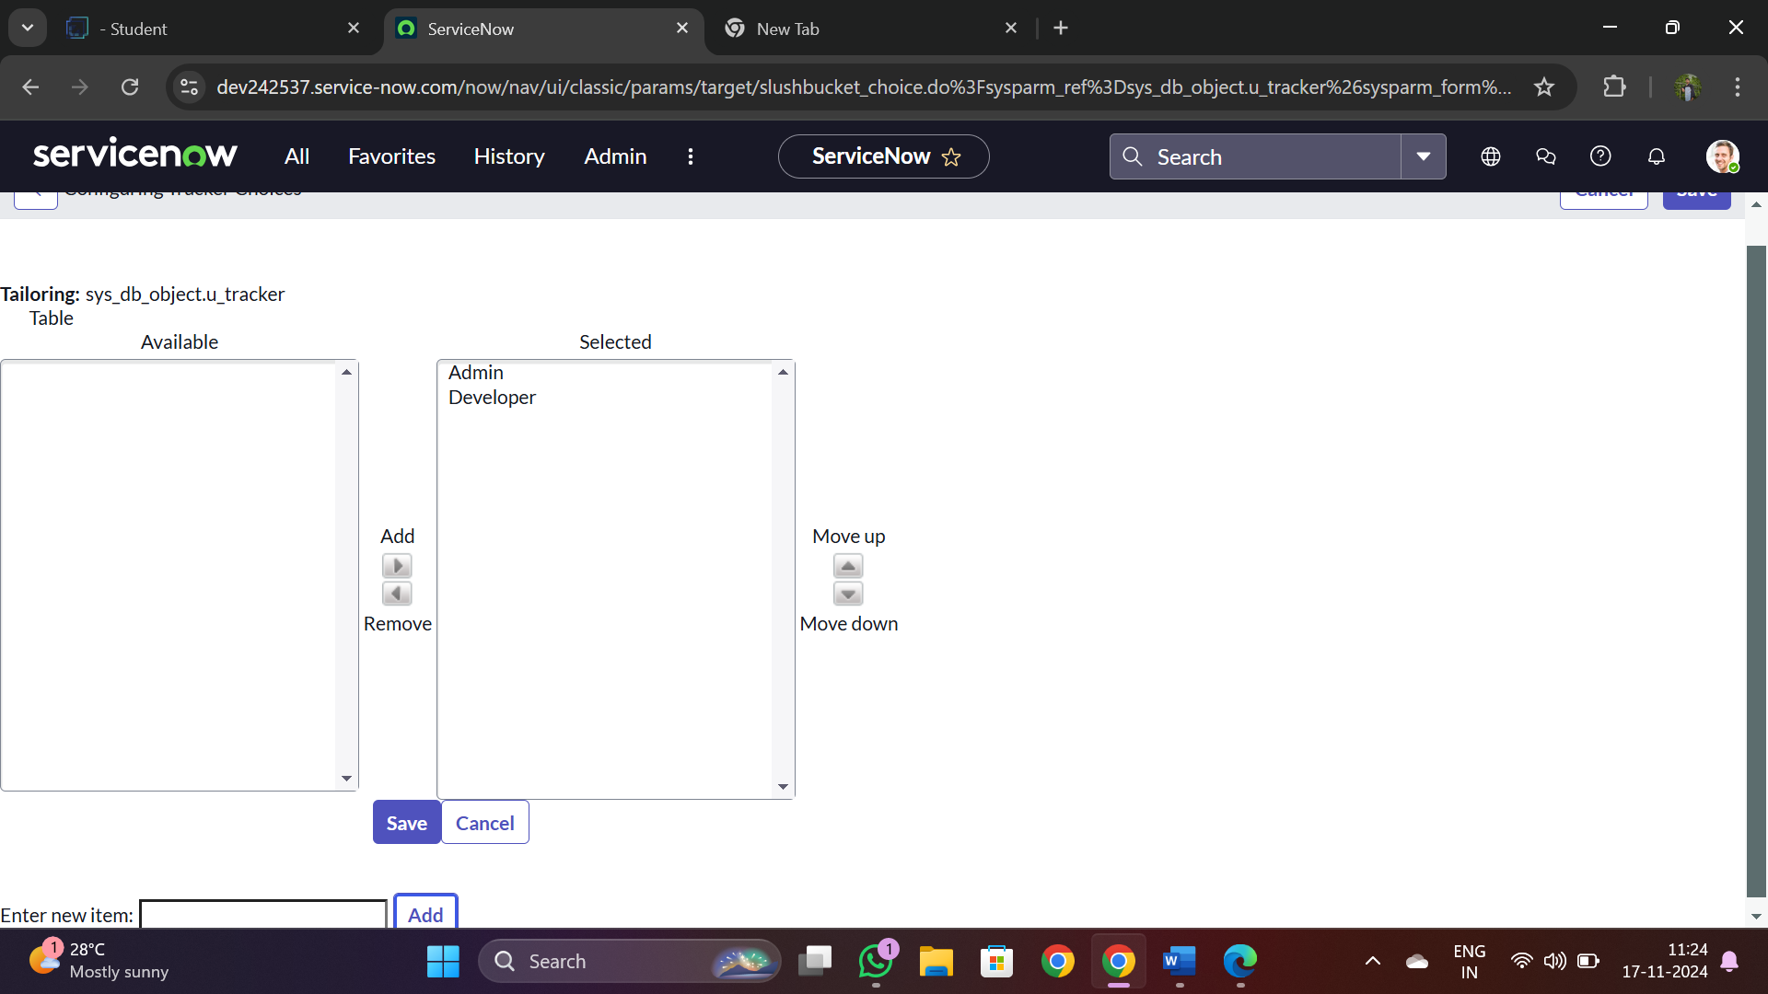

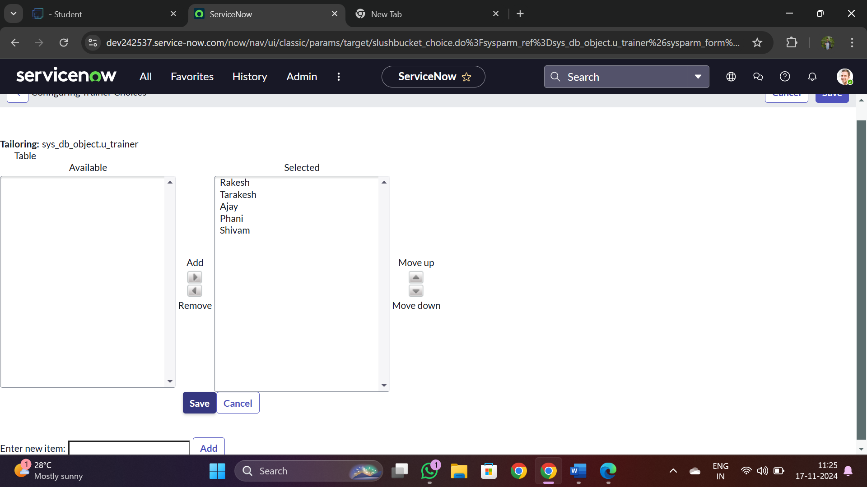

**Step 2 : Creating a custom matcher table.**



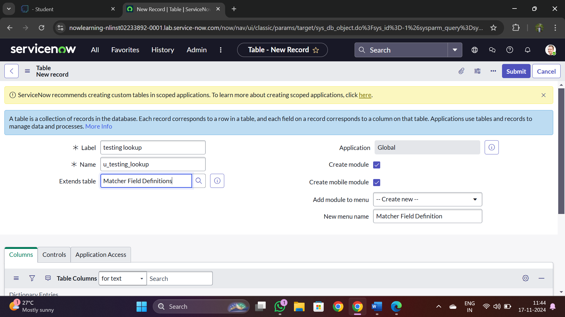

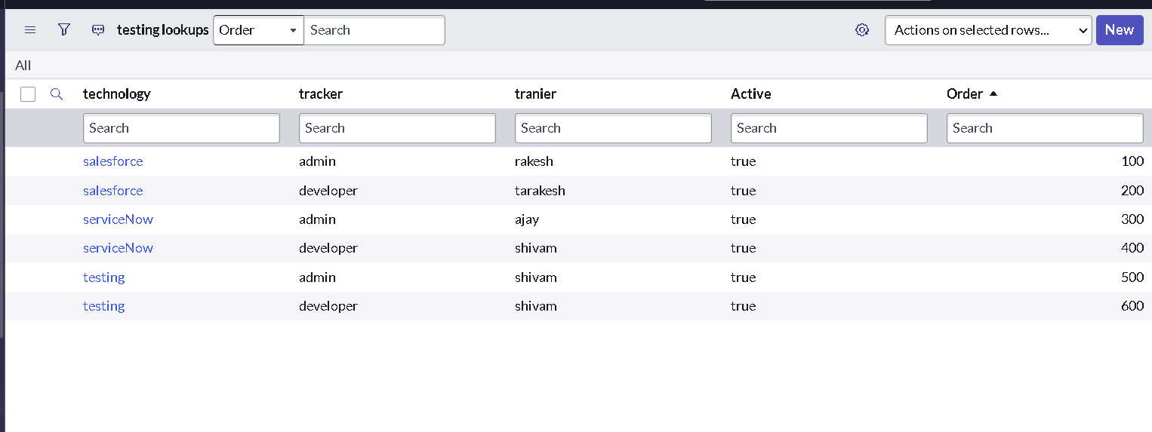

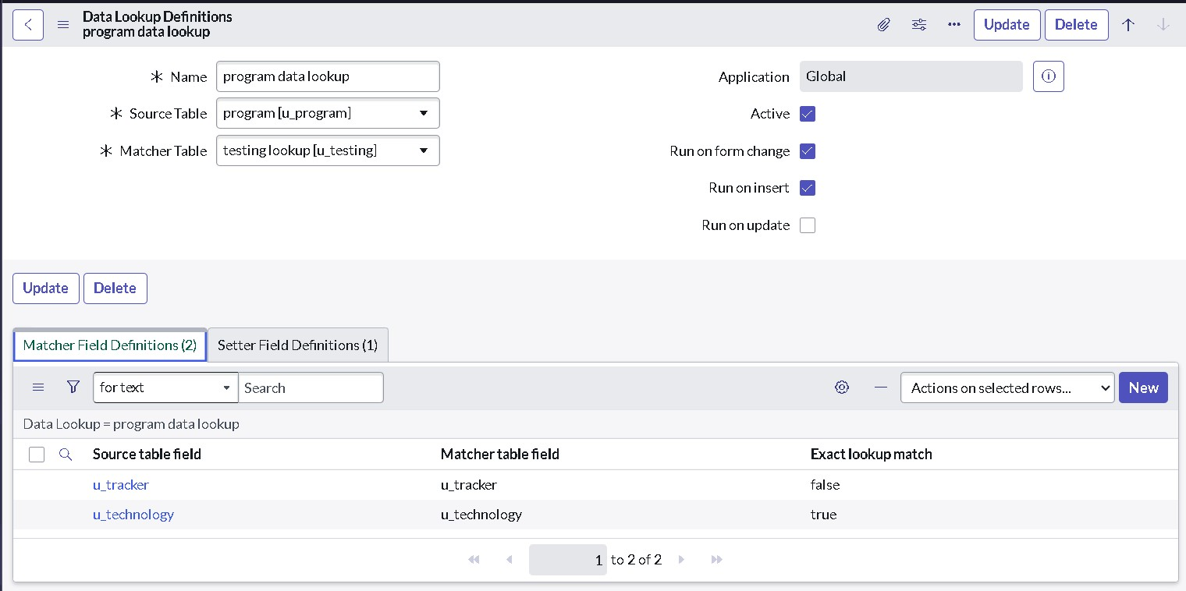

**Result**

* 1. Go to the source table “ program ”.
  2. Click on new .
  3. Select any technology and tracker .
  4. To check the trainer is automatically assigned to it.

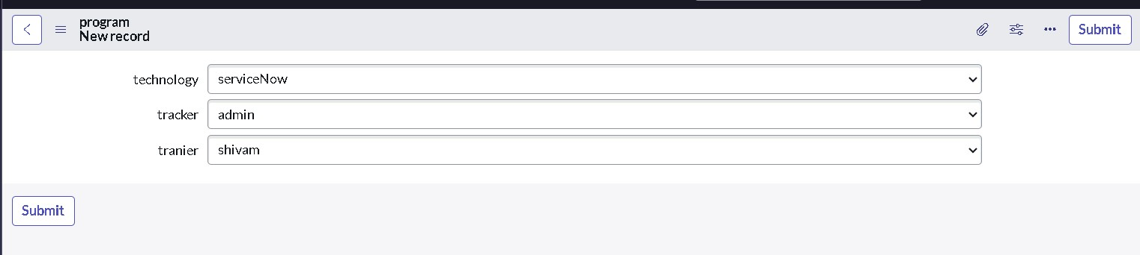

**Testing and Validation :**

**Automated Data Entry and Updates**

* + **Objective: Automate the process of entering or updating records in ServiceNow, such as incidents, changes, service requests, or program-related tasks, based on predefined rules.**
  + **Benefit: This reduces the need for manual data input and ensures that records are always up-to-date, saving time for the team and preventing human error.**

1. **Integration with External Data Sources** 
   * **Objective: Integrate ServiceNow with other platforms and systems, such as databases, APIs, or third-party applications, to automatically populate data into the system.**
   * **Benefit: Seamlessly sync data from various sources (e.g., CRM, HR systems, IT tools) to ServiceNow, ensuring that the program management team has a complete view of all relevant information.**
2. **Data Validation and Consistency Checks** 
   * **Objective: Implement automated validation rules to ensure data integrity and consistency before populating into ServiceNow.**
   * **Benefit: This ensures that only accurate and valid data is entered into the system, minimizing the chances of data-related issues affecting program management.**
3. **Reporting and Dashboard Automation** 
   * **Objective: Automate the creation of reports and dashboards for program management teams, drawing from data automatically populated in ServiceNow.**
   * **Benefit: This provides real-time insights into key metrics, program status, and resource allocation, allowing managers to make informed decisions quickly.**



**Key Scenario’s addressed by ServiceNow for implementation of project:**

**Creating a custom matcher table.**

* 1. Open “Tables” >> New.

Give the label name as “testing **Conclusion :**

In conclusion, automating data population in ServiceNow is a powerful approach to enhance program management by increasing efficiency, ensuring data accuracy, and optimizing workflows. By leveraging automation, organizations can reduce the burden of manual data entry, minimize human error, and keep data synchronized across integrated systems. The integration and automation of data-related processes provide program managers with timely insights, enabling better decision-making and resource allocation. Thorough testing and validation are essential to the success of the automation. By employing a comprehensive testing strategy that includes unit, integration, performance, security, and user acceptance testing, organizations can ensure that the automation functions correctly and aligns with business requirements. Continuous monitoring and exception handling mechanisms further guarantee the reliability and scalability of the solution over time. Ultimately, this project not only improves the operational efficiency of program management but also empowers teams to focus on strategic tasks, contributing to the overall growth and success of the organization. The automated solution will serve as a foundation for future enhancements and innovations in data management within ServiceNow.

* 1. lookup”.
  2. Add “Matcher Field Definition” in the Extends table field.
  3. Click on Submit**.**

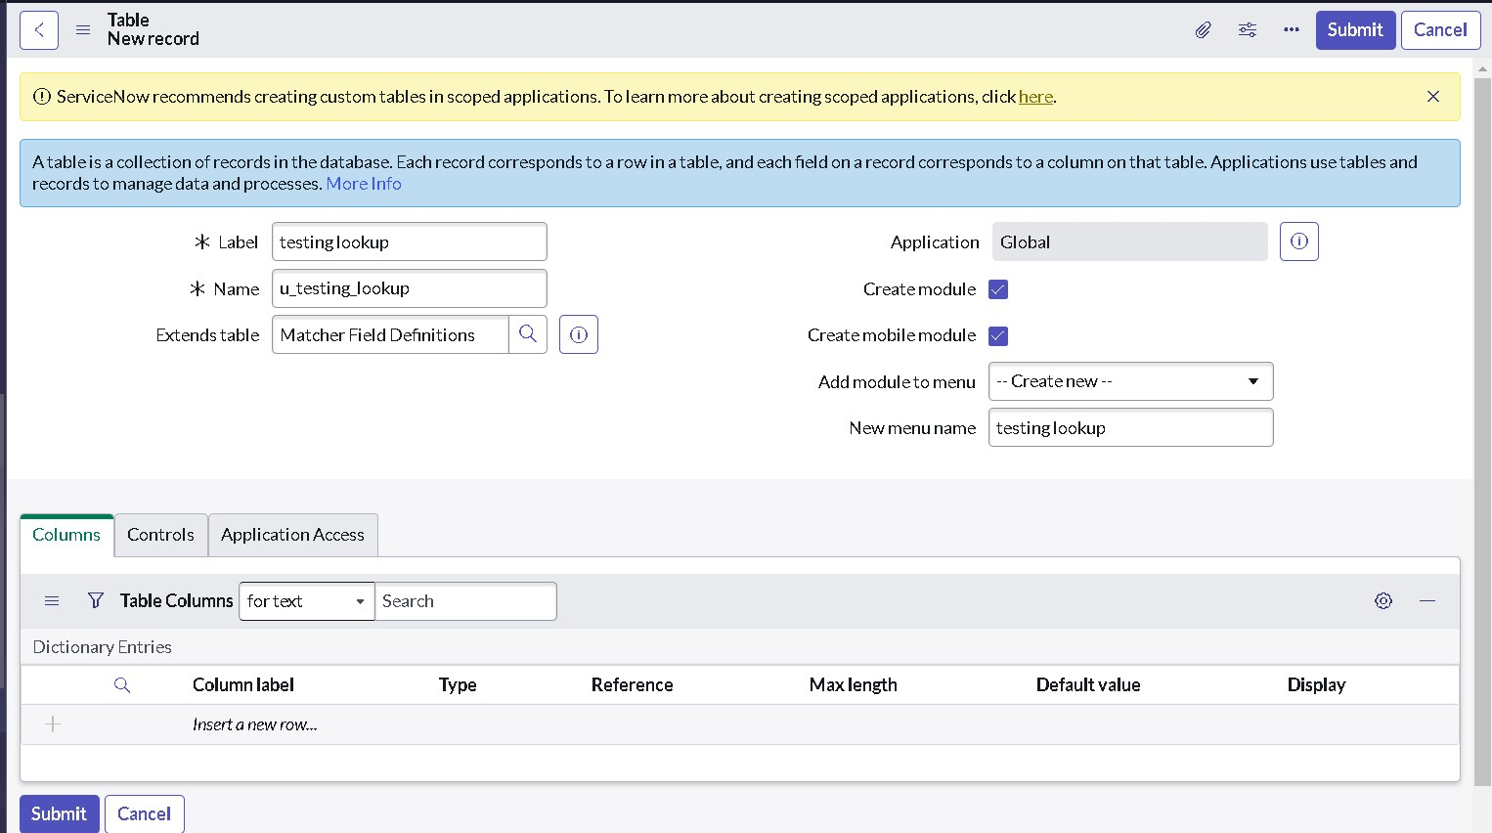

1. Follow the same steps from 4 to 17 from “step - 1”.
2. And add another field from the Form Layout that is “order”.
3. Click on save.

**Conclusion:**

In conclusion, automating data population in ServiceNow is a powerful approach to enhance program management by increasing efficiency, ensuring data accuracy, and optimizing workflows. By leveraging automation, organizations can reduce the burden of manual data entry, minimize human error, and keep data synchronized across integrated systems. The integration and automation of data-related processes provide program managers with timely insights, enabling better decision-making and resource allocation. Thorough testing and validation are essential to the success of the automation. By employing a comprehensive testing strategy that includes unit, integration, performance, security, and user acceptance testing, organizations can ensure that the automation functions correctly and aligns with business requirements. Continuous monitoring and exception handling mechanisms further guarantee the reliability and scalability of the solution over time. Ultimately, this project not only improves the operational efficiency of program management but also empowers teams to focus on strategic tasks, contributing to the overall growth and success of the organization. The automated solution will serve as a foundation for future enhancements and innovations in data management within ServiceNow.